# Issues in UAT:

## **Global Settings page:**

1. **Language change:**

Remarks: It does what it says here, but it is a question if the heading “Language options” should be changed to something like “Version options”. The first time I picked another ‘language’, I expected the text in the area with “Pre-defined lists” to be in the language that I picked, until I realized that this is steered by the normal language selection. So it is not really the language we are selecting, but the country specific version of the tool.

**The language of the text in the predefined list should be according to the language selected from the side menu not the normal language selection.**

1. **Delete potential incident:**

Remarks: It would not let me delete a potential incident (test1) that is in the list. Have tried several times, and first nothing happens, and then after maybe 5 seconds it comes a message in the down right corner saying “Something went wrong”.

**Test result: This issue was not be replicated. The potential incident can be deleting.**

## **Workshop page**:

1. **Record table edit:** (Issue 17)

Remarks: Nothing happened when clicking on the Update button (no reaction) after adding a barrier to an existing record.

**Test result: On the first two records the edit function was working fine, but on the third record I changed the consequence type and the current risk ranking field and while clicking on the update button nothing happened. 501 error occurred.**

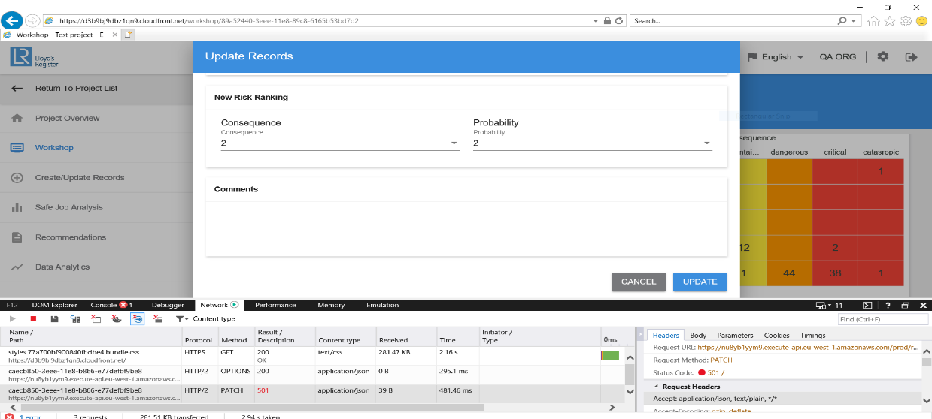

1. **Failure message when opening the Excel file downloaded from export records.**

Remarks: I got the following failure message (in Norwegian) when trying to open the Excel file. It says that there is problem with the content in the file, and asks if it should try to restore it. The file looked OK when opening it (but did not check it in detail, as for instance all formatting…)

**Test results: This issue occurred when a record was created without the barrier field and recommendation field.**

1. **Records are not showing after uploading.**

Remarks: At the first glimpse on the Workshop page, nothing was there after the import. But by clicking on one of the other menus on the left hand side, and then back to the Workshop page, the content had come in, both in the matrix and in the table below.

**Test result: This is a known issue in IE 11. The records are shown only after refreshing the page.**

1. **Records are not highlighted**

Remarks: Not possible to see any shading, but see that it is clickable by the format of the cursor (pointing hand).

**Test result: Cannot be replicated. The records are highlighted when the mouse is hovered over them and the pointer is changed.**

## **Safe Job Analysis page:**

1. **Words are divided in the middle in the summary doc**

Remarks: The Word file formatting is not as good as it should be – e.g. words are divided in the middle instead of being moved to the line below, and so on. Put an example of this at the end of this document.

**Test result: Known issue.**

1. **Would it be possible to have the Safe Job Analysis saved as Word (instead or in addition to save as PDF)?**

## **Create/Update records page:**

1. **Nothing happened when clicking on the Create New Button**

Remarks: I tried to create a new record (when going in through Create/update record). But that didn’t work, see screen shot (nothing happened when clicking on Create new, even if all necessary fields were filled out). Similar case that was reported in the existing version of the tool.

**Test result: Could not be replicated. An error message should be displayed why clicking the create new button if any required field is left out.**

## **Cache issue:**

When changing between different users, all information is not updated when going into the system. In the case below I had been in as [abcgeneral@lr.org](mailto:abcgeneral@lr.org) (that is project administrator and has been assigned to 3 projects), and I logged out and in again as [abcorg@lr.org](mailto:abcorg@lr.org) (the organization administrator). As you can see from the screenshot, only the three projects for the project administrator were visible on the screen (should have been 4 more). When clicking on a project, and then going out again, the correct screen is shown.

**Test result: This issue was there in IE 11 due to cache problem.**